Deployment Pipelines
- Premium / Fabric license required

- Go to https://app.powerbi.com/

- Create three workspaces
  - Power BI Dev
  - Power BI Test
  - Power BI Prod

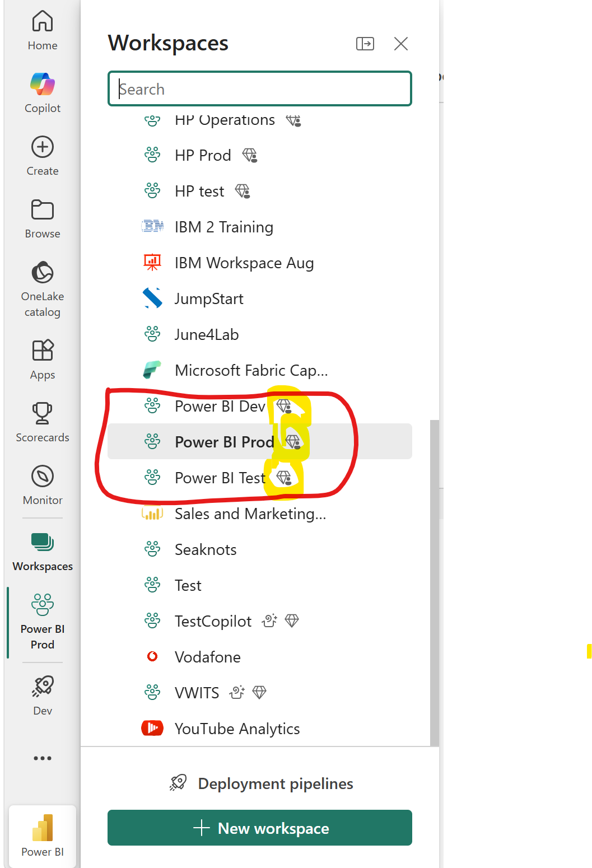

- Follow Day 4/Labs/1. Create a workspace.docx
- Assign license
- 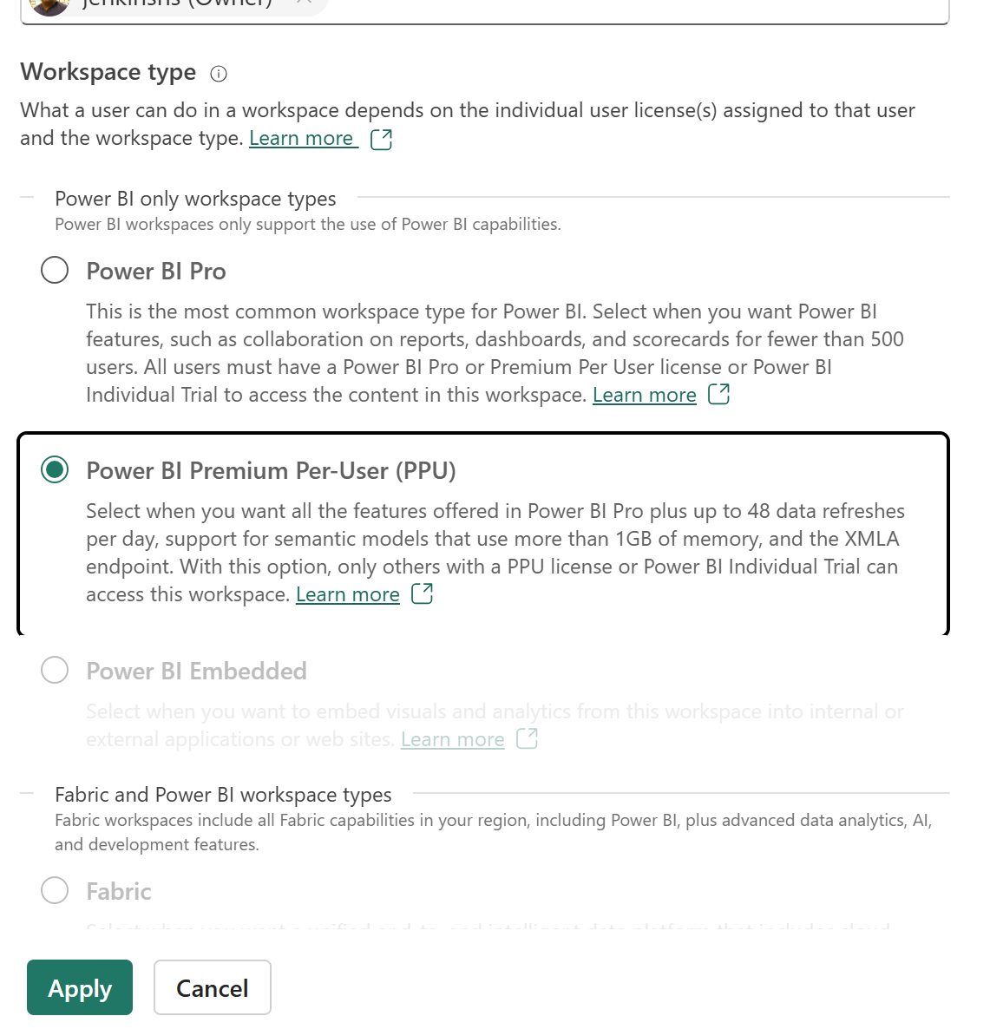
- Then create deployment Pipelines

- 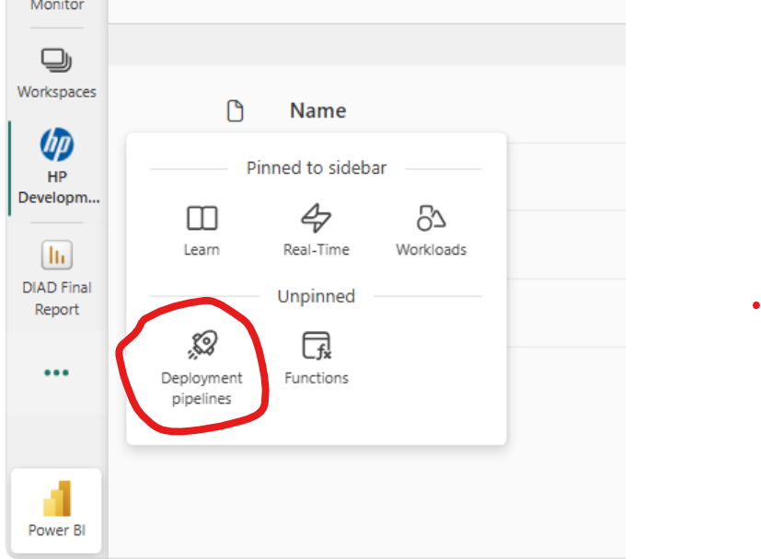

- Click Deployment Pipelines



- Click New Pipeline
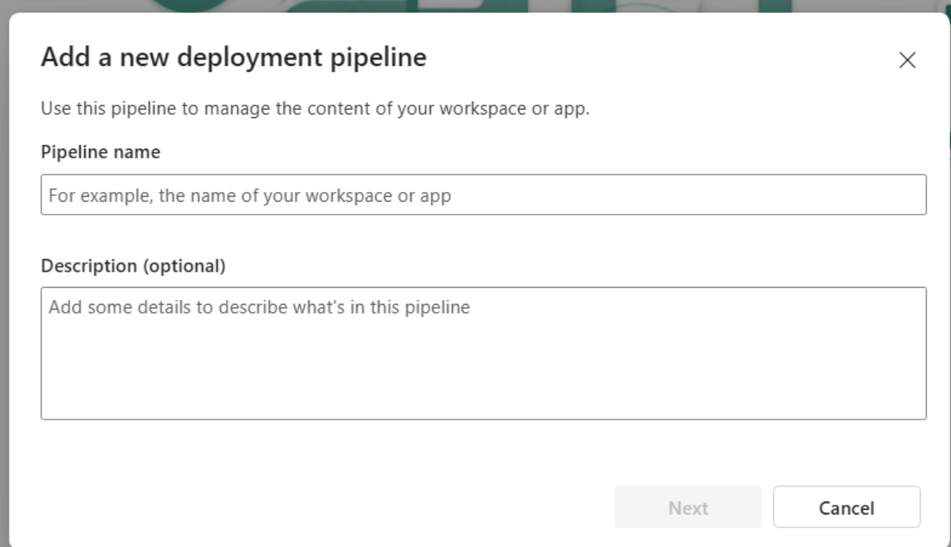
Pipeline Name and Description
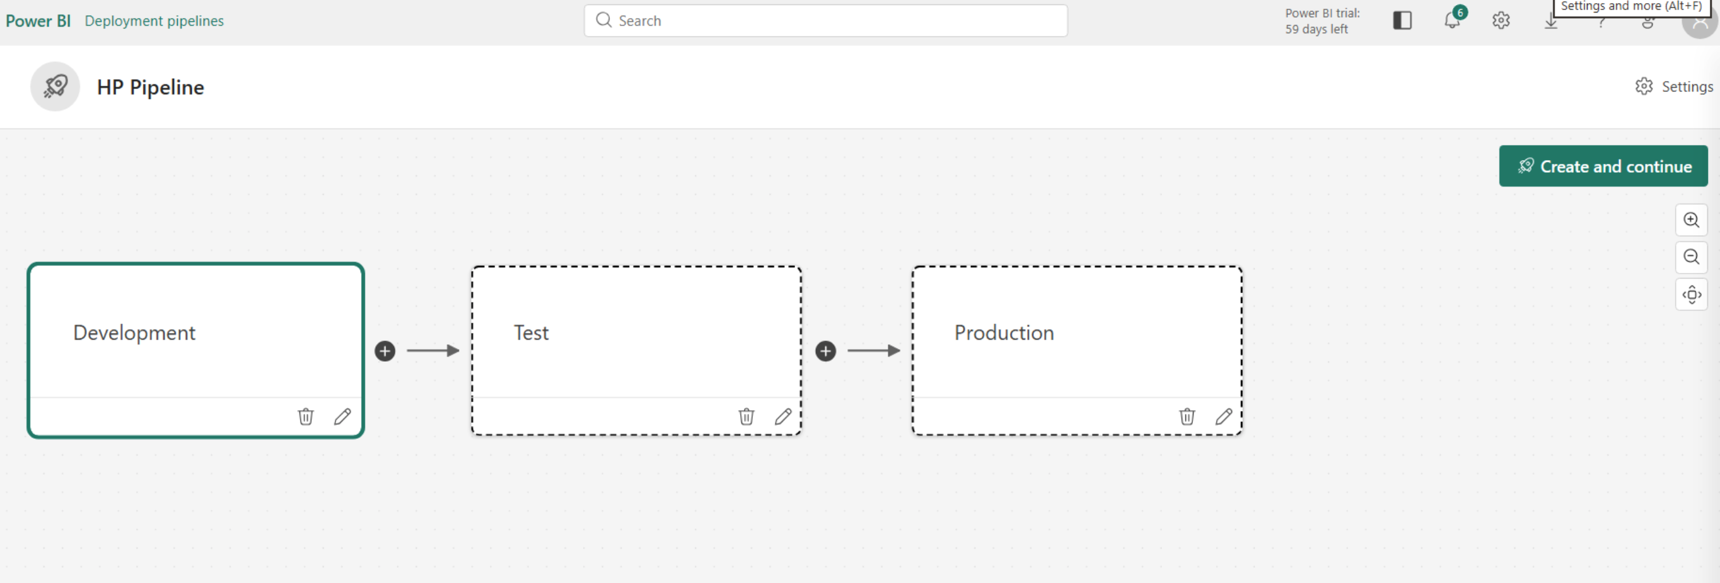

- Click create and continue
- Assign workspaces for all stages
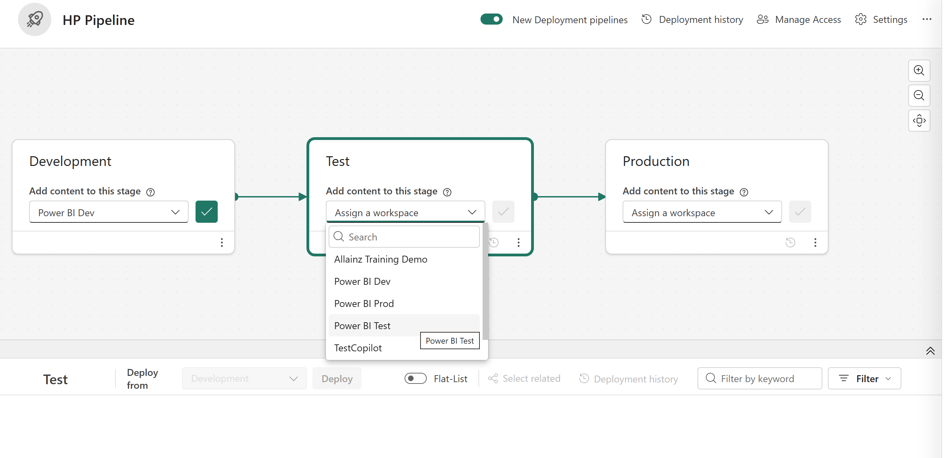
Click tick icon to save it

